Predictive power: AUC
Delete death and OS information and make the prediction by using our model
library(pROC)
## Type 'citation("pROC")' for a citation.
##
## Attaching package: 'pROC'
## The following objects are masked from 'package:stats':
##
## cov, smooth, var
lungSCC_predict <- select(lungSCC, -death, -OS)
lungSCC_predict$lp <- predict(lungSCC_multiCox, newdata=lungSCC_predict, type="lp")
roc(lungSCC$death,lungSCC_predict$lp,
smoothed = TRUE,
ci = TRUE, ci.alpha = 0.9, stratified = FALSE,
plot = TRUE, auc.polygon=TRUE, max.auc.polygon=TRUE, grid = TRUE,
print.auc=TRUE, show.thres=TRUE)
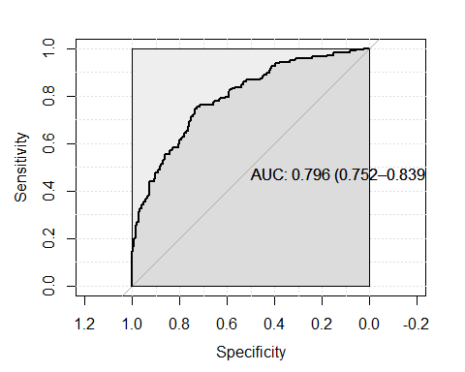
##
## Call:
## roc.default(response = lungSCC$death, predictor = lungSCC_predict$lp, ci = TRUE, plot = TRUE, smoothed = TRUE, ci.alpha = 0.9, stratified = FALSE, auc.polygon = TRUE, max.auc.polygon = TRUE, grid = TRUE, print.auc = TRUE, show.thres = TRUE)
##
## Data: lungSCC_predict$lp in 226 controls (lungSCC$death 0) < 172 cases (lungSCC$death 1).
## Area under the curve: 0.7956
## 95% CI: 0.7516-0.8395 (DeLong)
Interpretation: AUC-ROC curve is a performance measurement for classification problem. ROC is a probability curve and AUC represents degree of separability. It tells how much our model is capable of distinguishing between death status. Our model shows AUC 0.796 with 95% CI between 0.752-0.839 which means our model have around 80% accuracy
Model diagnostics: Case deletion residuals
dfbetas <- residuals(lungSCC_multiCox, type = 'dfbetas')
lungSCC$dfbetas <- sqrt(rowSums(dfbetas^2))
plot(lungSCC$dfbetas, type = 'h')
abline(h = 0)
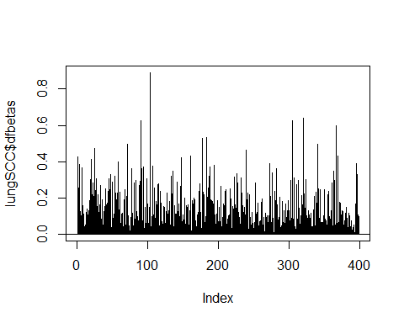 Interpretation: No specific observations as influentials that pull the regression toward them
Model diagnostic:Martingale Residuals Note that we do only sig features in final model Have to figure it out about underlying lung disease
lungSCC$residual <- residuals(lungSCC_multiCox, type="martingale")
par(mfrow = c(1,3), mar = c(4.2,2,2,2))
with(lungSCC, {
plot(AG,residual)
plot(cT, residual)
plot(pN, residual)
plot(pM, residual)
plot(Smoking_state, residual)
plot(FEV1_FVC, residual)
lines(lowess(FEV1_FVC, residual),lwd=2)
plot(meta, residual)
lines(lowess(meta, residual),lwd=2)
})
